Jenkins Challenge

Use the below code and implement our CICD stages.
- Source Code: https://github.com/betawins/hiring-app.git
  - Repository contains the application code for the hiring app.
- Create one Declarative pipeline job
- Create one Scripted pipeline job
- Create one multi stage pipeline job
- Create one parallel stage pipeline job

TITLE:
Implementation of Jenkins CI/CD Pipelines for Hiring Application.

OBJECTIVE:
To design and implement Jenkins CI/CD pipelines for the hiring application using different pipeline models—Declarative, Scripted, Multi-stage, and Parallel stage pipelines—in order to automate the process of source code checkout, code quality analysis, build, artifact management, deployment, and notification.

PREREQUISITES:
• Jenkins server installed and running
• Git installed on Jenkins server
• Source code repository available:
https://github.com/betawins/hiring-app.git
• Java and Maven installed on Jenkins server
• SonarQube server and Sonar Scanner configured
• Nexus Repository Manager configured for artifact storage
• Apache Tomcat server installed and accessible
• Required credentials configured in Jenkins:
- Git (if private repo)
- SonarQube token
- Nexus credentials
- Tomcat manager credentials
• Jenkins plugins installed:
- Git Plugin
- Pipeline Plugin
- SonarQube Scanner Plugin
- Credentials Plugin
- Slack Notification Plugin (optional)

STEP-BY-STEP-IMPLIMENTATION:
Created a job for declarative pipeline

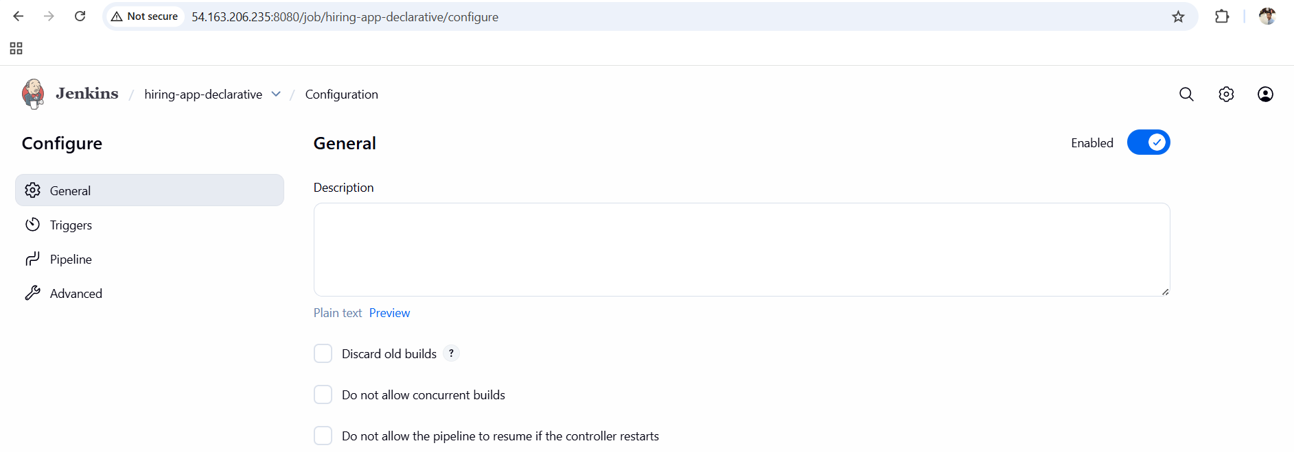

PIPELINE:

pipeline {
agent any

environment {
// Maven
MVN_HOME = "/opt/maven/bin/mvn"

// Sonar Scanner absolute path
SONAR_SCANNER = "/opt/sonar-scanner/bin/sonar-scanner"

// Nexus
NEXUS_URL = "http://98.93.29.69:8081/repository/simple-customer-app/"
GROUP_ID = "in.javahome"
ARTIFACT = "hiring"
VERSION = "0.1"

// Tomcat
TOMCAT_URL = "http://172.31.31.11:8080"
CONTEXT = "hiring"
}

stages {

stage('Git Clone') {
steps {
git url: 'https://github.com/betawins/hiring-app.git',
branch: 'main'
}
}

stage('SonarQube Integration') {
steps {
withSonarQubeEnv('sonarqube-server') {
sh '''
${SONAR_SCANNER} \
-Dsonar.projectKey=hiring-app \
-Dsonar.sources=. \
-Dsonar.java.binaries=target
'''
}
}
}

stage('Maven Compilation') {
steps {
sh '''
${MVN_HOME} clean package -DskipTests
'''
}
}

stage('Nexus Artifactory') {
steps {
withCredentials([usernamePassword(
credentialsId: 'nexus_credential',
usernameVariable: 'NEXUS_USER',
passwordVariable: 'NEXUS_PASS'
)]) {
sh '''
cat > settings.xml <<EOF
<settings>
<servers>
<server>
<id>simple-customer-app</id>
<username>${NEXUS_USER}</username>
<password>${NEXUS_PASS}</password>
</server>
</servers>
</settings>
EOF

${MVN_HOME} deploy:deploy-file \
-s settings.xml \
-DgroupId=${GROUP_ID} \
-DartifactId=${ARTIFACT} \
-Dversion=${VERSION} \
-Dpackaging=war \
-Dfile=target/${ARTIFACT}.war \
-DrepositoryId=simple-customer-app \
-Durl=${NEXUS_URL}
'''
}
}
}

stage('Deploy on Tomcat') {
steps {
withCredentials([usernamePassword(
credentialsId: 'tomcat_credentials',
usernameVariable: 'TC_USER',
passwordVariable: 'TC_PASS'
)]) {
sh '''
curl -u ${TC_USER}:${TC_PASS} \
"${TOMCAT_URL}/manager/text/undeploy?path=/${CONTEXT}" || true

curl -u ${TC_USER}:${TC_PASS} \
-T target/${ARTIFACT}.war \
"${TOMCAT_URL}/manager/text/deploy?path=/${CONTEXT}&update=true"
'''
}
}
}
}

post {
success {
slackSend(
channel: '#jenkins-integration',
color: 'good',
message: " hiring-app CI/CD Pipeline SUCCESS"
)
}
failure {
slackSend(
channel: '#jenkins-integration',
color: 'danger',
message: " hiring-app CI/CD Pipeline FAILED"
)
}
}
}

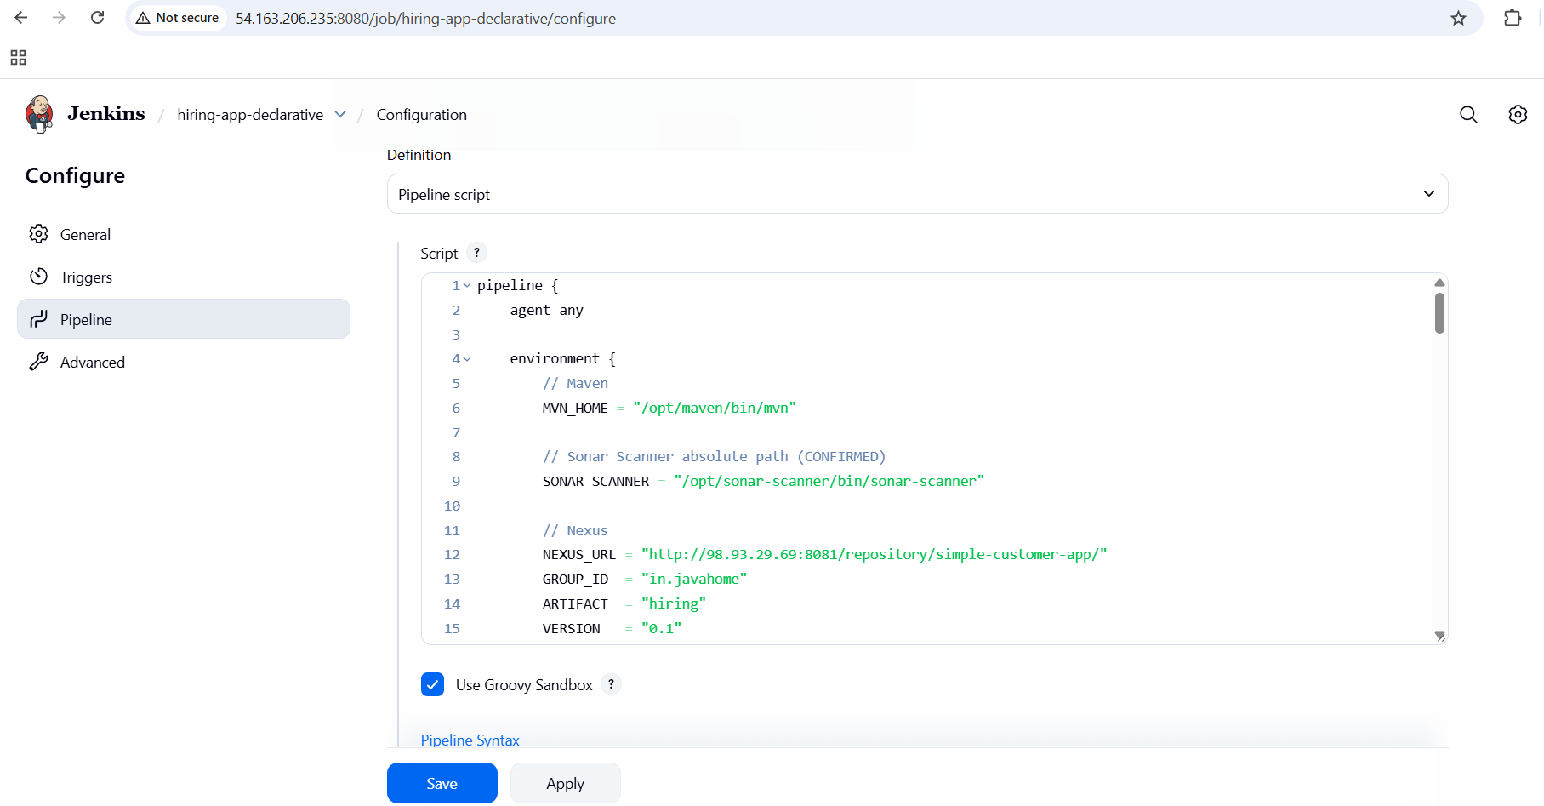

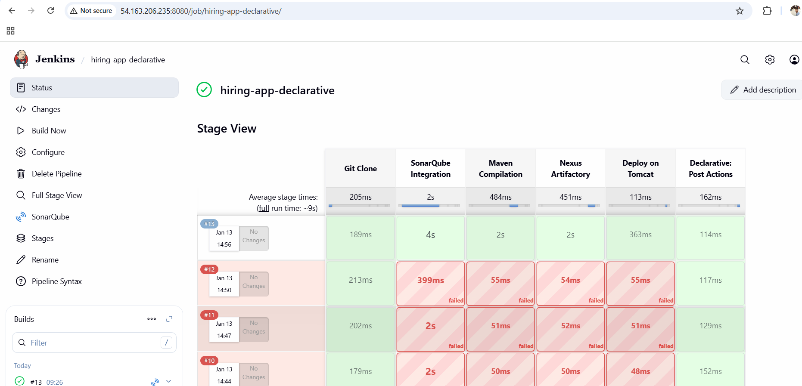

Created a job for scripted pipeline

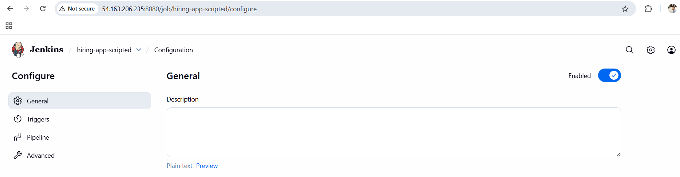

PIPELINE:

node {

// Environment variables (same as declarative)
env.MVN_HOME = "/opt/maven/bin/mvn"
env.SONAR_SCANNER = "/opt/sonar-scanner/bin/sonar-scanner"

env.NEXUS_URL = "http://98.93.29.69:8081/repository/simple-customer-app/"
env.GROUP_ID = "in.javahome"
env.ARTIFACT = "hiring"
env.VERSION = "0.1"

env.TOMCAT_URL = "http://172.31.31.11:8080"
env.CONTEXT = "hiring"

try {

stage('Git Clone') {
git url: 'https://github.com/betawins/hiring-app.git',
branch: 'main'
}

stage('SonarQube Integration') {
withSonarQubeEnv('sonarqube-server') {
sh """
${env.SONAR_SCANNER} \
-Dsonar.projectKey=hiring-app \
-Dsonar.sources=. \
-Dsonar.java.binaries=target
"""
}
}

stage('Maven Compilation') {
sh """
${env.MVN_HOME} clean package -DskipTests
"""
}

stage('Nexus Artifactory') {
withCredentials([usernamePassword(
credentialsId: 'nexus_credential',
usernameVariable: 'NEXUS_USER',
passwordVariable: 'NEXUS_PASS'
)]) {

sh """
cat > settings.xml <<EOF
<settings>
<servers>
<server>
<id>simple-customer-app</id>
<username>\${NEXUS_USER}</username>
<password>\${NEXUS_PASS}</password>
</server>
</servers>
</settings>
EOF

${env.MVN_HOME} deploy:deploy-file \
-s settings.xml \
-DgroupId=${env.GROUP_ID} \
-DartifactId=${env.ARTIFACT} \
-Dversion=${env.VERSION} \
-Dpackaging=war \
-Dfile=target/${env.ARTIFACT}.war \
-DrepositoryId=simple-customer-app \
-Durl=${env.NEXUS_URL}
"""
}
}

stage('Deploy on Tomcat') {
withCredentials([usernamePassword(
credentialsId: 'tomcat_credentials',
usernameVariable: 'TC_USER',
passwordVariable: 'TC_PASS'
)]) {

sh """
curl -u \${TC_USER}:\${TC_PASS} \
"${env.TOMCAT_URL}/manager/text/undeploy?path=/${env.CONTEXT}" || true

curl -u \${TC_USER}:\${TC_PASS} \
-T target/${env.ARTIFACT}.war \
"${env.TOMCAT_URL}/manager/text/deploy?path=/${env.CONTEXT}&update=true"
"""
}
}

stage('Slack Notification') {
slackSend(
channel: '#jenkins-integration',
color: 'good',
message: " hiring-app CI/CD Pipeline SUCCESS"
)
}

} catch (err) {

stage('Slack Notification') {
slackSend(
channel: '#jenkins-integration',
color: 'danger',
message: " hiring-app CI/CD Pipeline FAILED"
)
}

throw err
}
}

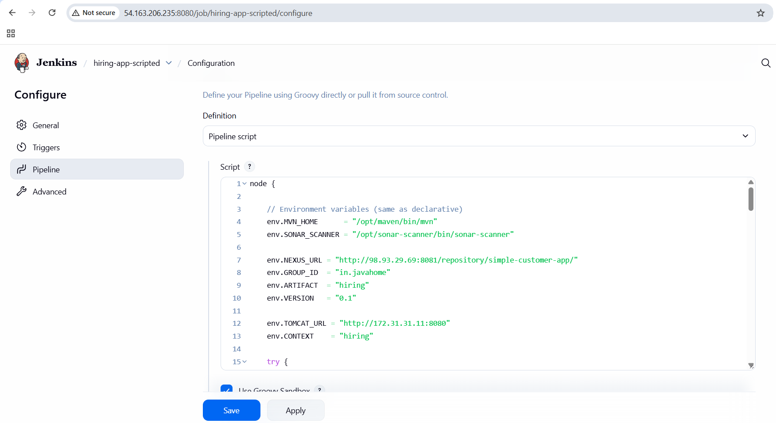
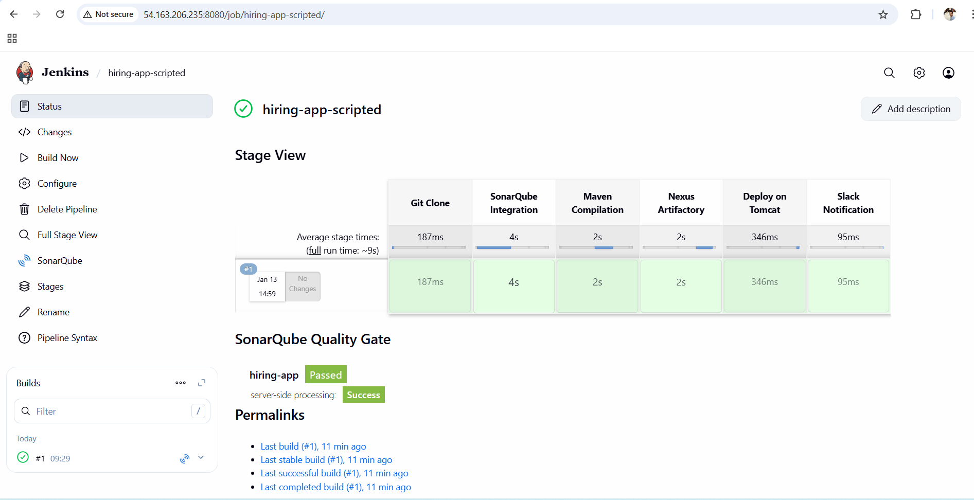

Created a job for multi stage pipeline

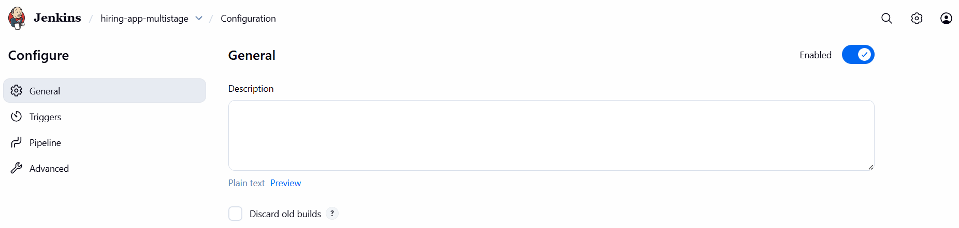

PIPELINE:

pipeline {
agent any

environment {
// Maven
MVN_HOME = "/opt/maven/bin/mvn"

// Sonar Scanner absolute path
SONAR_SCANNER = "/opt/sonar-scanner/bin/sonar-scanner"

// Nexus
NEXUS_URL = "http://98.93.29.69:8081/repository/simple-customer-app/"
GROUP_ID = "in.javahome"
ARTIFACT = "hiring"
VERSION = "0.1"

// Tomcat
TOMCAT_URL = "http://172.31.31.11:8080"
CONTEXT = "hiring"
}

stages {

stage('Git Clone') {
steps {
git url: 'https://github.com/betawins/hiring-app.git',
branch: 'main'
}
}

stage('SonarQube Integration') {
steps {
withSonarQubeEnv('sonarqube-server') {
sh '''
${SONAR_SCANNER} \
-Dsonar.projectKey=hiring-app \
-Dsonar.sources=. \
-Dsonar.java.binaries=target
'''
}
}
}

stage('Maven Compilation') {
steps {
sh '''
${MVN_HOME} clean package -DskipTests
'''
}
}

stage('Nexus Artifactory') {
steps {
withCredentials([usernamePassword(
credentialsId: 'nexus_credential',
usernameVariable: 'NEXUS_USER',
passwordVariable: 'NEXUS_PASS'
)]) {
sh '''
cat > settings.xml <<EOF
<settings>
<servers>
<server>
<id>simple-customer-app</id>
<username>${NEXUS_USER}</username>
<password>${NEXUS_PASS}</password>
</server>
</servers>
</settings>
EOF

${MVN_HOME} deploy:deploy-file \
-s settings.xml \
-DgroupId=${GROUP_ID} \
-DartifactId=${ARTIFACT} \
-Dversion=${VERSION} \
-Dpackaging=war \
-Dfile=target/${ARTIFACT}.war \
-DrepositoryId=simple-customer-app \
-Durl=${NEXUS_URL}
'''
}
}
}

stage('Deploy on Tomcat') {
steps {
withCredentials([usernamePassword(
credentialsId: 'tomcat_credentials',
usernameVariable: 'TC_USER',
passwordVariable: 'TC_PASS'
)]) {
sh '''
curl -u ${TC_USER}:${TC_PASS} \
"${TOMCAT_URL}/manager/text/undeploy?path=/${CONTEXT}" || true

curl -u ${TC_USER}:${TC_PASS} \
-T target/${ARTIFACT}.war \
"${TOMCAT_URL}/manager/text/deploy?path=/${CONTEXT}&update=true"
'''
}
}
}
}

post {
success {
slackSend(
channel: '#jenkins-integration',
color: 'good',
message: " hiring-app CI/CD Pipeline SUCCESS"
)
}
failure {
slackSend(
channel: '#jenkins-integration',
color: 'danger',
message: " hiring-app CI/CD Pipeline FAILED"
)
}
}
}

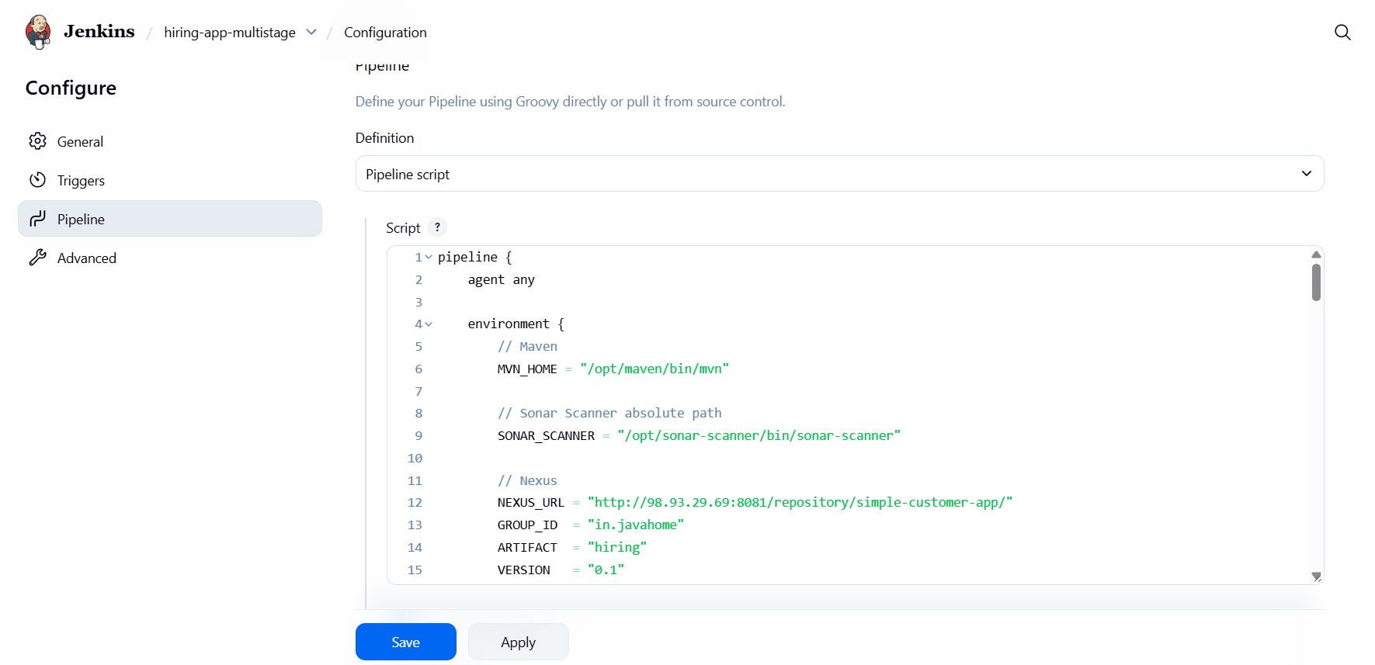

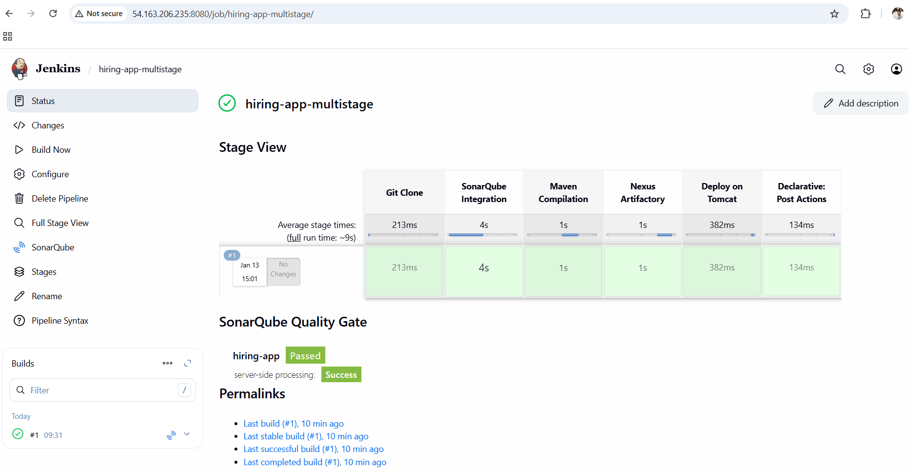

Created a job for Parallel stage pipeline

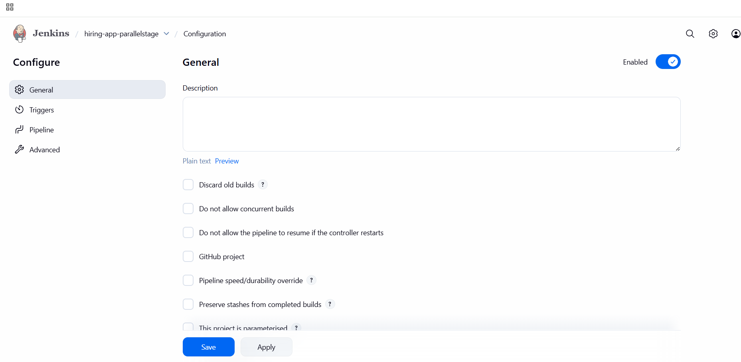
PIPELINE:

ipeline {
agent any

environment {
// Maven
MVN_HOME = "/opt/maven/bin/mvn"

// Sonar Scanner absolute path
SONAR_SCANNER = "/opt/sonar-scanner/bin/sonar-scanner"

// Nexus
NEXUS_URL = "http://98.93.29.69:8081/repository/simple-customer-app/"
GROUP_ID = "in.javahome"
ARTIFACT = "hiring"
VERSION = "0.1"

// Tomcat
TOMCAT_URL = "http://172.31.31.11:8080"
CONTEXT = "hiring"
}

stages {

stage('Git Clone') {
steps {
git url: 'https://github.com/betawins/hiring-app.git',
branch: 'main'
}
}

stage('Parallel CI Stages') {
parallel {

stage('SonarQube Integration') {
steps {
withSonarQubeEnv('sonarqube-server') {
sh '''
${SONAR_SCANNER} \
-Dsonar.projectKey=hiring-app \
-Dsonar.sources=. \
-Dsonar.java.binaries=target
'''
}
}
}

stage('Maven Compilation') {
steps {
sh '''
${MVN_HOME} clean package -DskipTests
'''
}
}
}
}

stage('Nexus Artifactory') {
steps {
withCredentials([usernamePassword(
credentialsId: 'nexus_credential',
usernameVariable: 'NEXUS_USER',
passwordVariable: 'NEXUS_PASS'
)]) {
sh '''
cat > settings.xml <<EOF
<settings>
<servers>
<server>
<id>simple-customer-app</id>
<username>${NEXUS_USER}</username>
<password>${NEXUS_PASS}</password>
</server>
</servers>
</settings>
EOF

${MVN_HOME} deploy:deploy-file \
-s settings.xml \
-DgroupId=${GROUP_ID} \
-DartifactId=${ARTIFACT} \
-Dversion=${VERSION} \
-Dpackaging=war \
-Dfile=target/${ARTIFACT}.war \
-DrepositoryId=simple-customer-app \
-Durl=${NEXUS_URL}
'''
}
}
}

stage('Deploy on Tomcat') {
steps {
withCredentials([usernamePassword(
credentialsId: 'tomcat_credentials',
usernameVariable: 'TC_USER',
passwordVariable: 'TC_PASS'
)]) {
sh '''
curl -u ${TC_USER}:${TC_PASS} \
"${TOMCAT_URL}/manager/text/undeploy?path=/${CONTEXT}" || true

curl -u ${TC_USER}:${TC_PASS} \
-T target/${ARTIFACT}.war \
"${TOMCAT_URL}/manager/text/deploy?path=/${CONTEXT}&update=true"
'''
}
}
}
}

post {
success {
slackSend(
channel: '#jenkins-integration',
color: 'good',
message: " hiring-app CI/CD Pipeline SUCCESS"
)
}
failure {
slackSend(
channel: '#jenkins-integration',
color: 'danger',
message: " hiring-app CI/CD Pipeline FAILED"
)
}
}
}

